# Neurophysics 2015 – Exercise 3

Richard Hahnloser

**Solutions of Joachim Ott and Benjamin Ellenberger**

## Download the sound file ZebraFinch.wav and compute the song spectrogram.

1. Choose a window size and overlap size to obtain a nice spectrogram like in Figure 1. Do you choose linear or logarithmic scaling?

Log scale

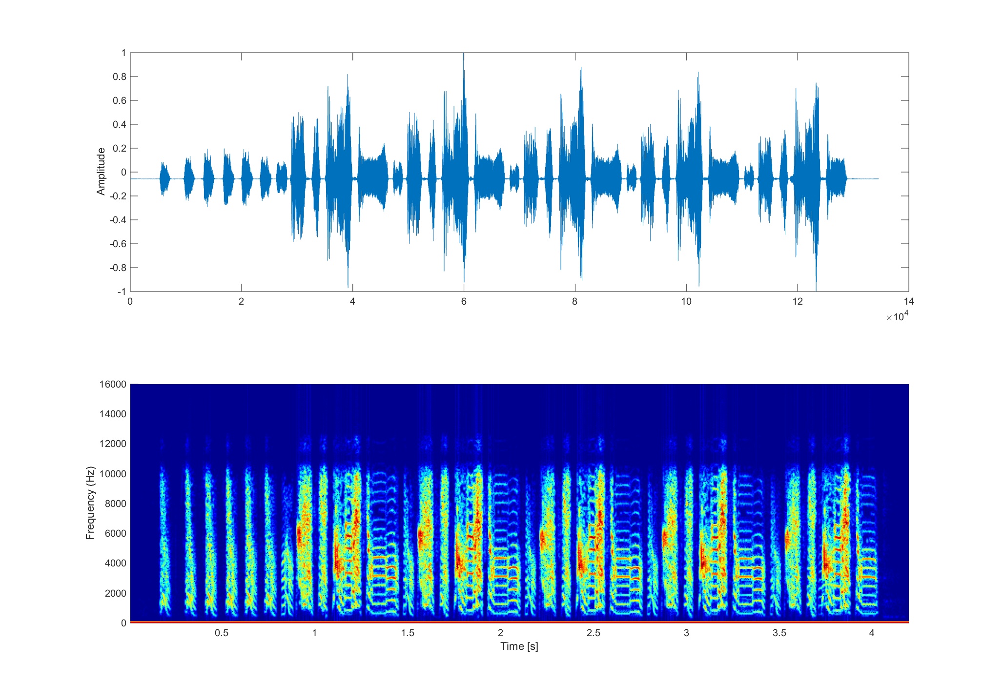

1. How many introductory notes does this bird sing? 6

How many song motifs? 5 times

How many syllables is the motif composed of? 5

Can you eyeball the pitch (frequency) of the long harmonic stack? 600Hz

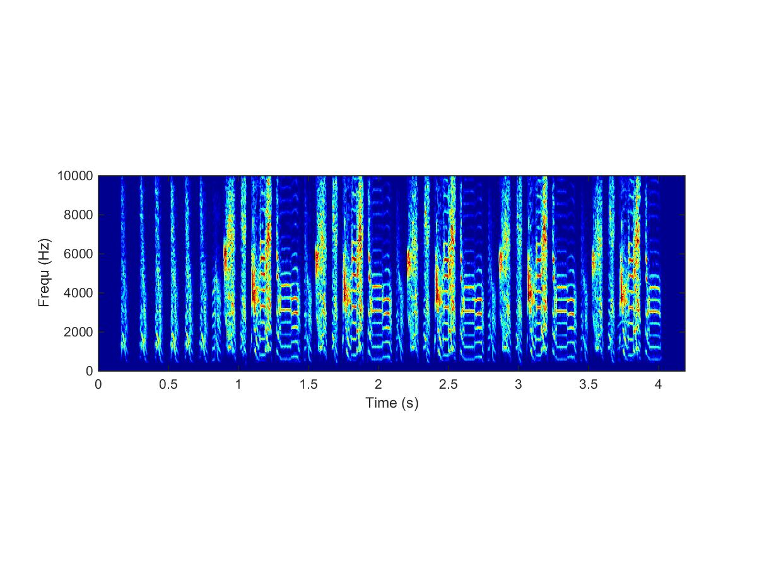

Figure : Sound spectrogram of ZebraFinch.wav

## Compute the antidromic spike latency and spike latency variability of one HVC projection neuron and one HVC interneuron

Download the data files Neuron1.mat and Neuron2.mat. Each contains antidromic spike responses recorded from a neuron in the nucleus interface of the ndiopallium (NIf). The stimulation electrode was implaned in HVC. The time stamps (x1) are in milliseconds.

Plot of both neurons:

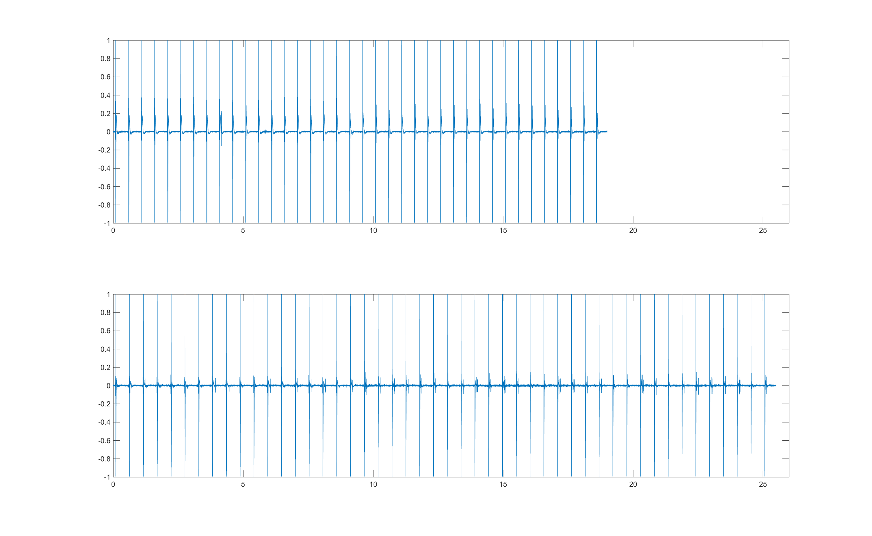

Perform the following tasks on the data

1. Identify the stimulus artifact and the spike waveform

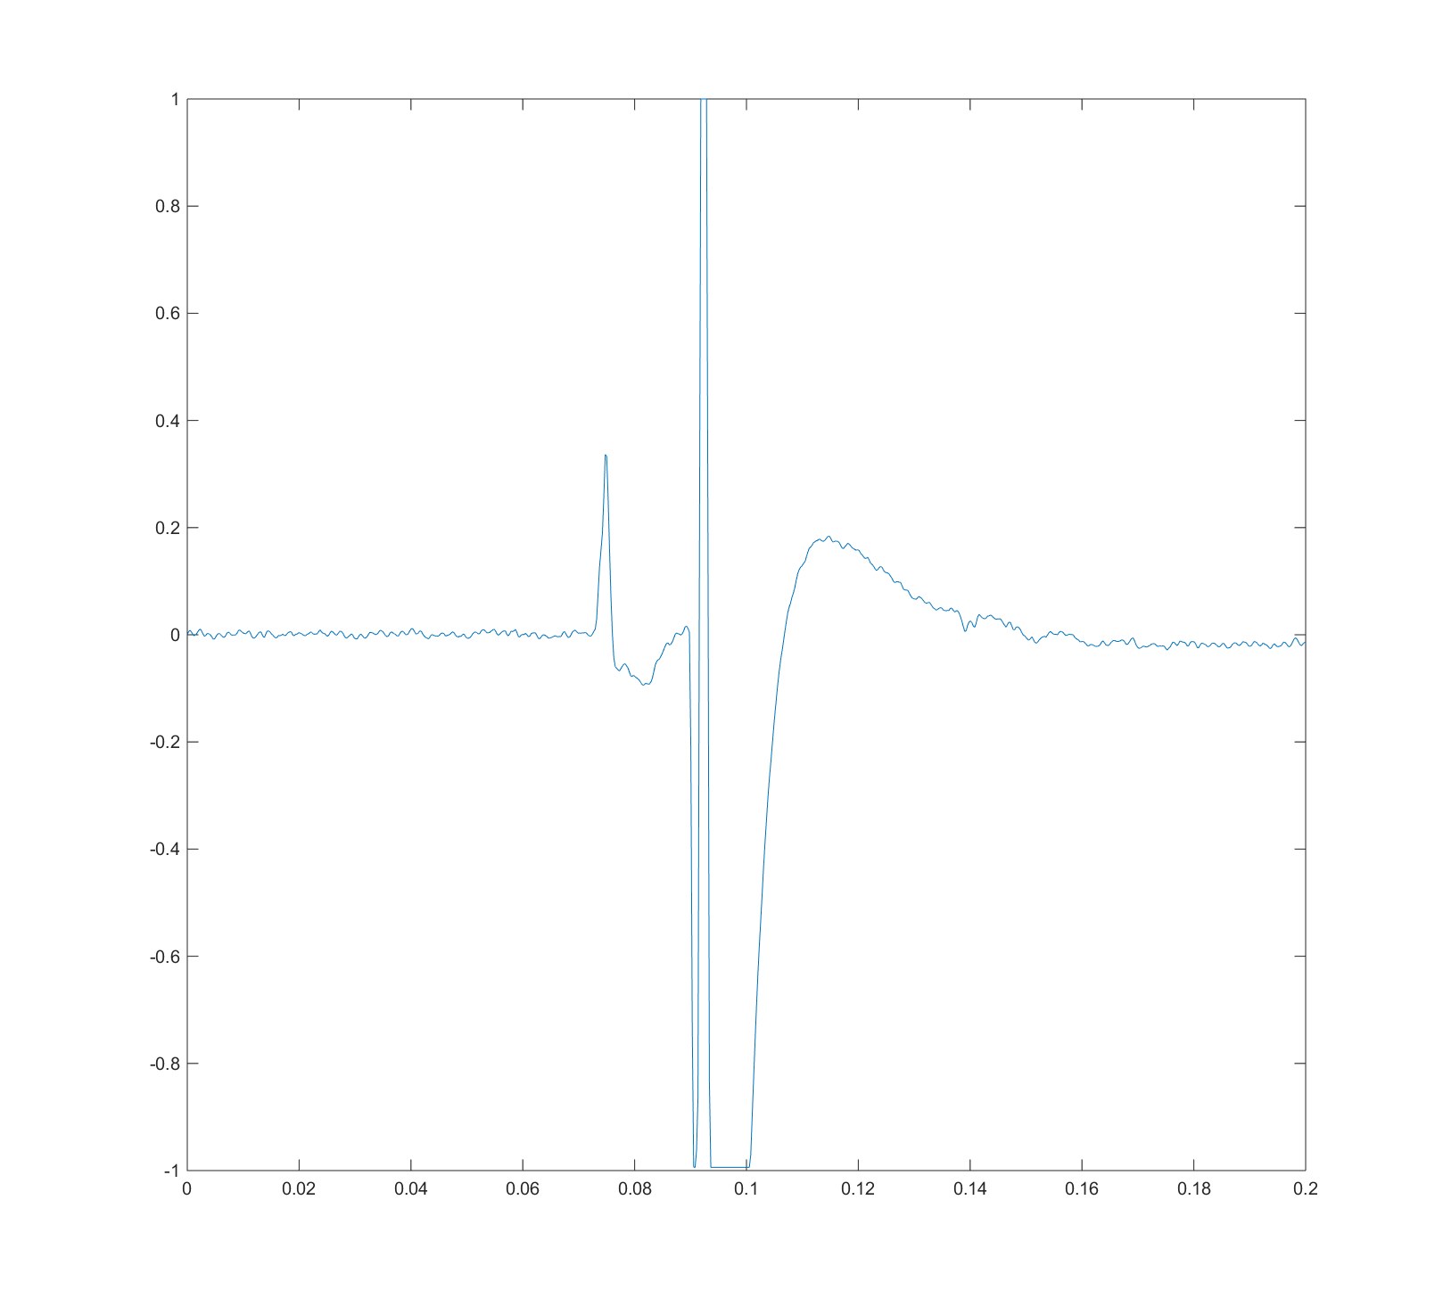

The stimulus artifact is the signal that ranges from -1 to 1

1. Identify the instances in which a spike collision occurred and instances in which no collision occurred.

A couple are visible with the zoom function in matlab…

1. Compute the antidromic spike latency and the spike latency variability of the two neurons.
2. Identify which among the two is an interneuron and which one is a HVC projecting neuron.